Greetings, let’s get started on another week of distance learning. This week, I’ll be hosting our class first MS Teams session. All sessions are 20 – 30 minutes.

* On **Wednesday, April 22, 2020 at 1:00 p.m.** students and parents can join me for a **Q&A session and informative updates.**
* On **Friday, April 24, 2020 at 11:00a.m.** students can participate in **math review and instruction.**

**Instructional and Support Schedule**

**Office Hours**

**Monday, Wednesday, and Friday**

9:00a.m.- 11:00a.m.

**Tuesday and Thursday**

3:00p.m.- 5:00p.m.

**Contact Information**

**Email:** [reddings@leonschools.net](mailto:reddings@leonschools.net)

**Remind App:** Class Code @msredding1

**Note:** Please allow me 24 - 48 hours to reply to emails and Remind Messages. All text messaging should now take place through the remind app.

* Did you know your child can write and type on **Wonders** online worksheets? Be sure to expand the screen to access all tools. Press the disk to save and I’ll be able to see their work.
* Don’t forget to check out our **Special Area Teachers**. Students receive grades for **P.E, Art, and Music**. These teachers have posted assignments for students to complete and submit.
* Remember assignments are graded and should be turned in weekly.

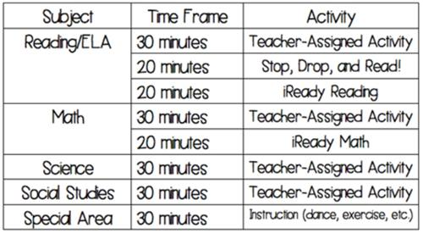

# Virtual High Five

These students have completed or made adequate progress on week 3 assignments.

Maalia Daley

Marcus Henryhand

Khiyon Lewis

Heaven Robinson

Braydin Smith

Distance Learning Journey

# Updates and Helpful Tips

# Week 4: Growth Mindset

banner with apples and crayons

### Astoria Park Elementary School

Tallahassee, Fl

Newsletter

April 13, 2020

Volume 1, Issue 2

Ms. Redding’s Classroom Newsletter

Suggested Schedule



Ms. Reddings’s Classroom Newsletter Page 2

**Language Arts:** Students will be responsible for Wonders Your Turn Pages weekly and Weekly Assessments. Students can access all assignments and additional resources daily through **Classlink** and selecting **ConnectEd**

**Unit 5 Week 2:**

* **Phonics:** er, ir, ur
* **Comprehension Skill**: Cause and Effect
* **Words to Know**: another, full, climb, through, poor, great

**Math**: Students should access assignments on **ThinkCentral App**. Chapter 7 Assessment and Lessons 8.2- Mid-Chapter Checkpoint are due by April 29, 2019

**Science: Submit Via Email or Remind**

**Florida Standard**: SC.1.L.14.3. Students will differentiate between living and nonliving things.

Assignment: Neighborhood Stroll

Are you tired of being in the house? This is a great time to get some exercise in and take a stroll or just hang out in the yard. There are living and nonliving things all around us.

* While on your walk make a list of at least 10 things that you see.
* Make a T- Chart. One side should be labeled living and the other side nonliving.
* Sort and write the name of each object under the correct category.

Example

|  |  |
| --- | --- |
| Living Things | Nonliving Things |
| grasshopper | mailbox |
|  |  |

**Social Studies**

**Florida Standard: SS.1.C.2.3.** Students will identify ways can participate in the betterment of their school and community.

Assignment: We all have a responsibility to help make our communities a pleasant place to living, work, and learn. During this unforeseen time we have witnessed many people help each other and make our communities better. Even a child can have a positive impact on the people in your community.

**Write at least 3 sentences identifying ways you can make your community better. Draw a picture showing you doing positive things to impact your community. Think about the current stay of our nation, how can you help during this crisis?**

**Rubric**

|  |  |  |  |
| --- | --- | --- | --- |
| 100 A   * Neat Handwriting * 3- 5 sentences * Answered prompt clearly * Grammar Rules Followed * Illustration | 89- 80 B   * Legible Handwriting * 2 sentences * Answered prompt Some Grammar Errors * Illustration | 79- 70C   * Legible Writing * 1 sentence * Does not stay on topic * Many Grammar Errors * Illustration does not match sentence | 69- 60D   * Illegible Writing * Incomplete Sentences * Ignores Grammar * No Illustration |

# This Week’s Assignments